**STATES OF MATTER**

**INTRODUCTION :**

Matter is made up of atoms or molecules. The arrangement of these molecules determines the state of matter. There are three recognised state of matter : Solid, Liquid and Gas. Matter can change between states when the temperature or pressure is changed. State changes of matter are physical rather than chemical.

**DIFFERENCE BETWEEN STATES OF MATTER :**

|  |  |  |  |
| --- | --- | --- | --- |
|  | Gas | Liquid | Solid |
| i. | Assume the shape and volume of its container. | Assumes the shape of the part of the container which it occupies. | Retains a fixed volume and Shape. |
| ii. | Particles can move past one another. | Particles can move/slide past one another. | Rigid-particles locked into place. |
| iii. | Compressible, lots of free space between particles. | Not easily compressible, little space between particles. | Not easily compressible, Very little free space between particles. |
| iv. | Flows easily, particles can move past one another. | Flows easily, particles can move/slide past one another. | Does not flow easily, rigid-particles cannot move/slide one past another. |
| v. | Low density | Intermidiate density | High density |
| vi. | Very small intermolecular attraction but high kinetic energies | Considerable intermolecular attraction, kinetic energy is less. | Intermolecular forces are high, vibrational motion only. |

**GASEOUS STATE**

**1 . Important properties of gases :**

**(i) Mass** : Mass in gm = Moles × Molecular mass.

**(ii) Volume** : Volume of the gas is the volume of container in which they are filled in.

**(iii) Temperature** : Temperature of a gas is the measure of kinetic energy of gas. Kinetic energy ∝ Temperature

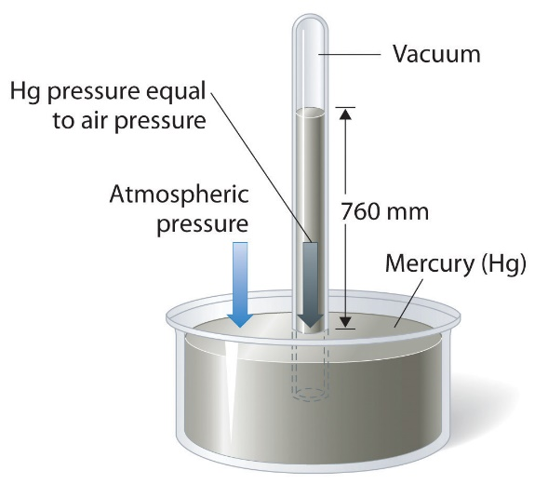**(iv) Pressure** : Pressure of gas is defined as the force exerted by the gas on the walls of its container. It is often assumed that pressure is isotropic, i.e. it is the same in all the three directions.

**BAROMETER**

Where....

h = height of the mercury column supported by the barometer.

d = density of mercury.

g = acceleration due to gravity.

**2 . Units and determination of pressure of gas :**

1. In SI unit the unit of pressure is the pascal (N/m2) instead, the unit bar, kPa or MPa is used

1 bar = 105 N/m2 = 100 kN/m2 = 100 kPa

1. Pressure are also stated in mm or cm of mercury.

1 atm = 760 mm Hg = 1.01325 bar = 1.01325 × 105 Pa = 101.325 KN/m2 = 1.0332 Kgf/cm2

1 Pa = 1 Nm–2 = 1 Kgm–1 S–1

1L atm = 101.325 J

(d) The pressure relative to the atmosphere is called gauge pressure. The pressure relative to the perfect vacuum is called absolute pressure.

Absolute pressure = Gauge pressure + Atmosphere pressure

(e) When the pressure in a system is less than atmospheric pressure, the gauge pressure becomes negative, but is frequently designated and called vacuum. For example, 16 cm vacuum will be –

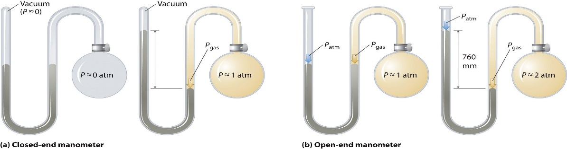

**MANOMETER**

(f) Pressure is measured using a manometer which is a simple device with a horizontal arm and a U-tube carrying mercury or any other suitable liquid.

**Ex.** Calculate the mass of mercury in a uniform column 760 mm high and 1.00 cm2 in cross-sectional area. Is there any change in.

(a) mass and

(b) pressure of column of same height but with 2.00cm2 cross sectional area is taken ?

(density of Hg = 13.6 g/cm3)

**Sol.** 760 mm = 76 cm

∴ V = 76 × 1 = 76 cm3

∴ Mass = V × d = 76 × 13.6 = 1033.6 g

1. If area of cross-section is 2cm2 (doubled) then volume is also doubled hence,

∴ Mass = 76 × 2 × 13.6 = 2067.2 g

(b) This mass would rest on twice the area and so exert the same pressure.

**GAS LAWS**

The gas laws are a set of laws that describe the relationship between thermodynamic temperature (T), pressure (P) and volume (V) of gases.

**1 . Boyle's law : (Temprature – Volume Relationship)**

It states ***"****at a constant temperature (T), the pressure (P) of a given mass (or moles, n) of any gas varies inversely with the volume (V)****".***

Pressure (P) and volume (V) of gases

For two or more gases at constant temperature:

P1V1 = P2V2 = ..... = K

**Graphical representation :**

**

**These plots drawn at constant temperature for a gas are called Isotherms.**

**Ex 1.** The diameters of a bubble at the surface of a lake is 4 mm and at the bottom of the lake is 1 mm. If atmospheric pressure is 1 atm and the temperature of the lake-water and the atmosphere are equal, what is the depth of the lake ? (The density of lake-water and Hg are 1 gm/ml and 13.6 gm/ml respectively. Also neglect the contribution of pressure due to surface tension).

**Sol**. The pressure on the bubble = 1 atm (when it is at the surface)

The pressure on the bubble = P atm (say) (when it is at the bottom)

The volume of the bubble = 1/6 π (0.1)3

P × 1/6 π × (0.1)3 = 1 × 1/6 π (0.4)3

or P = 64 atm. Thus the pressure due to water is 63 atm (∴ atmospheric pressure = 1 atm)

Now, consider the depth of lake is h cm

∴ 63 × 76 × 13.6 × g = h × 1 × g

or h = 63 × 76 × 13.6 cm = 65116.8 cm.

**Ex.** An iron tank contains helium at a pressure of 3.0 atm at 27ºC. The tank can withstand a maximum pressure of 10 atm. The building in which tank has been placed catches fire predict whether the tank will blow up first or melt. (melting point of iron is 1535ºC)

Sol. P1 = 3.0, T1 = 300 K



⇒ 3.0/300=P2/1808

P2 = 3.0 × 1808/300 = 18.08 atm

Since at melting point it is greater than the maximum pressure, therefore it will blow up.

**2 . Charles's law : (Temperature – Volume Relationship)**

It states "at constant pressure, the volume of a given mass of a gas, increases or decreases by 1/273.15 th of its volume at 0ºC for every rise or fall of one degree in temperature".

Or

According to Charles’ law the volume occupied by a fixed amount of gas is directly proportional to its absolute temperature.

V T

i.e. The volume of a given gas is proportional to the absolute temperature.

**Graphical representation :**

**Graphs between V and T at constant pressure are called Isobars.**

**3 . Gay Lussac's law : (Pressure – Temperature Relationship)**

It states "at constant volume, the pressure of a given mass of a gas is directly proportional to the absolute temperature of the gas".

**Graphical representation :**

**The plots drawn at constant volume for a gas is called as Isochore.**

**The combined gas law :**

It states "for a fixed mass of gas, the volume is directly proportional to absolute temperature and inversely proportional to the pressure".

**Volume coefficient (αv) of a gas** **:**

The ratio of increase in volume of a gas at constant pressure per degree rise of temperature to its volume at 0ºC is the volume coefficient of the gas.

**Pressure coefficient (αp) of a gas :**

The ratio of increase in pressure of the gas at constant volume per degree rise of temperature to its pressure at 0ºC is the pressure coefficient of the gas.

**4. Avogadro Law ( Volume – Amount Relationship)**

It states that equal volumes of all gases under the same conditions of temprature and pressure contain equal number of molecules,

Mathematically we can write,

V n

Where n is the number of moles of the gas.

* V = kn



**THE IDEAL GAS EQUATION**

An ideal gas is defined to be a system in which there are no inter molecular/interatomic forces. Such a system can only exist as a gas. Any real system will approach ideal gas behaviour in the limit that the pressure is extremely low and the temperature is high enough to overcome attractive intermolecular forces.

An ideal gas is a gas to go which the laws of Boyle and Charles are strictly applicable under all conditions of temperatures and pressures.

****From Boyle's law we get,

****From charles law we get,

****From Avogadro's law we get,

Combining the above three equations we get

Ideal gas equation is a relation between four variables and it describes the state of any gas. For this reason, it is also called Equation of State.

**Dimension of R :**

**Physical significance of R :**

The dimentions of R are energy per mole per kelvin and hence it represents the amount of work (or energy) that can be obtained from one mole of a gas when its temperature is raised by 1K.

**Units of R :**

**# TRICK**

**We will use this formula instead of using various Gas laws to avoid confusion.**

**REMEMBER : There must be no chemical reaction before using this formula.**

**Do It Yourself**

**Q:** A vessel of 120ml capacity contains a certain amount of gas at 35°C and 1.2 bar pressure. The gas is transferred to another vessel of volume 180ml at 35°C. What would be its pressure ?

1. 1.2 bar (c) 0.8 bar
2. 2.0 bar (d) 0.4 bar

[HINT: Use Trick (Practiced in class)]

**Q:** Two glass bulbs A and B are connected by a very small tube having a stop-cock. Bulb A has a volume of 100 cm3 and contains a gas while bulb B is empty. On opening the stop-clock, the pressure falls down to 40%. The volume of the bulb B must be

1. 75 cm3 (c) 125 cm3
2. 150 cm3 (d) 250 cm3

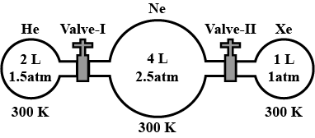**Q:**

**4.0L**

**6.0L**

**4.1 atm**

**0.82 atm atm**

**2 atm atm**

**10.0L**



Than calculate:

1. The pressure of He gas after open valve-1
2. The pressure of He gas after open Valve-1 and Valve-2 both

**Q:** Two closed vessel of equal volume containing air at pressure P1 and temperature T1­ are connected to each other through a narrow tube. If the temperature in one of the vessels is now maintained at T1 and that in the other at T2 what will be the pressure in the vessels.

**Q:**A student foeget to add the reaction mixture to the round bottomed flask at 27°C but instead he placed the flask on the flame. After a lapse of time, he relized his mistake and using a pyrometer he found the temperature of the flask was 477°C. what fraction of air would have been expelled out ?

**DALTON'S LAW OF PARTIAL PRESSURES**

Dalton's law of partial pressure states "at a given temperature, the total pressure exerted by two or more non-reacting gases occupying a definite volume in equal to the sum of the partial pressures of the component gases."

Dalton's law of partial pressure is applicable only to non-reacting gases.

If the two non-reacting gases A and B having nA and nB number of moles respectively are filled in a vessels of volume V at temperature T, Then

Partial pressure may be calculated as

PA = XA × P, similarly PB = XB × P

Partial pressure of a component = Mole fraction × total pressure.

It has been observed that gases are generally collected over water and therefore are moist.

Pdry gas = Pmoist gas – Pwater vapour

The pressure exerted by water vapour is constant with water at a particular temperature is called as aqueous tension, which varies directly with the temperature and becomes 760 mm at 100ºC.

Pressure of dry gas = Pressure of moist gas – aqueous tension